EXPERIMENT NO. 1
STUDY OF MEASUREMENT OF ANTENNA PARAMETERS USING SPECTRUM ANALYSER AND VECTOR NETWORK ANALYZER (VNA)

EXPERIMENT NO:1
STUDY OF MEASUREMENT OF ANTENNA PARAMETERS USING SPECTRUM ANALYSER AND VECTOR NETWORK ANALYZER (VNA)

AIM: To study the measurement of antenna parameters using Spectrum Analyzer and VNA.
APPARATUS REQUIRED:
Spectrum Analyzer- 3GHz, Cables with SMA and N type of connectors
THEORY:
Antennas are a key element in any communication or radar system. As higher frequencies are considered for automotive radar or for 5G communication systems, beam widths shrink and path loss increases, making accurate characterization of radiation patterns essential. This is especially true in systems utilizing simple or massive multiple input, multiple output (MIMO) antenna designs, where over the air (OTA) testing is the only practical means to verify performance. As a result, engineers need cost effective, simple to use antenna measurement solutions for measuring and characterizing antenna systems. Some of the available instruments are Spectrum Analyzer and Vector Network Analyzer (VNA).
- Spectrum Analyzer
The spectrum analyzer is an electronic device that is used for measuring the magnitude of the input signal against the frequency in an instrument. It does this in the entire range of the instrument’s frequency bandwidth. It is useful to measure the spectrum powers of both the known and unknown signals in an electrical instrument. Although the primary signal that is fed into the spectrum analyzer is electrical, it also analyzes the spectral compositions of acoustic waves and light waves through the use of a proper transducer. This analyzer is advantageous in understanding the parameters of electronic devices, especially wireless transmitters because the spectral workings of the instrument in terms of signals, distortions, frequency and power can be easily observed. These are otherwise hard to detect in time domain waveforms.
SPECTRUM ANALYZER SPECIFICATIONS:
GSP-830 Characteristics:
The GSP-830 is a mid-to-high range digital storage spectrum analyzer suitable for a wide variety of applications, such as production testing, research, and field verification.

Performance:
• Low noise floor: typical -117dBm @1GHz, 3k RBW
• Fast sweep: 50ms to 25.6s
• Compact size: 330(W) x 170(H) x 340(D) mm
• Light weight: approx. 6kg

Features:
• Autoset
• 5 markers with delta marker and peak functions
• 3 traces
• Power measurements: ACPR, OCBW, N-dB, PhaseJitter
• Pass/fail test with limit line editing
• Split windows with separate settings
• Sequence programming (user-defined macro)
• 6.4″ TFT color LCD, 640 x 480 resolution
• Phone output (available in the optional Demodulator)
• AC/DC/battery multi-mode power operation

Interface:
• USB host for storage device connection
• USB slave/RS232/GPIB (optional) for PC software connection and remote control
• Direct VGA display image output
• Reference signal input/output for synchronization
• External trigger signal input

- LCD DISPLAY:

The Display setting configures the LCD screen dimmer level, display line, display title, and split window. Display line provides a convenient reference line for measuring amplitude. Split window allows two simultaneous waveforms to be shown on the display. The VGA connector on the rear panel outputs the LCD screen contents in 640 x 480 resolutions.

FRONT PANEL OVERVIEW
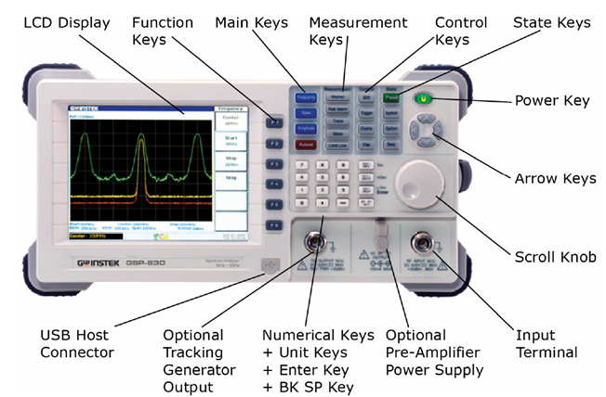
Fig 1.1 Front panel overview
REAR PANEL OVERVIEW
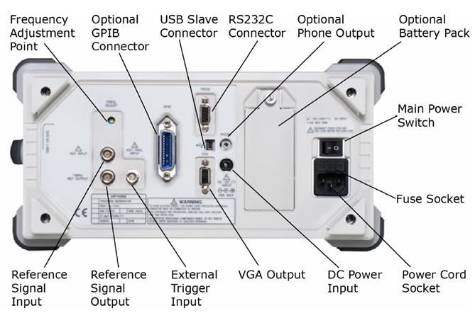
Fig 1.2 Rear panel overview
- TRACKING GENERATOR

The optional Tracking Generator (Opt.01) is a factory installed item which generates a sweep signal with its sweep time and frequency range matching the GSP-830system. The amplitude is maintained to a constant value over the entire frequency range, which is very useful for testing the frequency response of the DUT.

2.1 Procedure to Activate Tracking Generator

2.1.1. Activate TG output
1. Press the Option key.
2. Press F1 (TG)F 1
3. Press F1 (TG ON)
4. The tracking generator output becomes activated.

2.1.2. Set TG output level
1. Press F2 (TG Level) 2
2. Change the TG output level using the Numerical keys and Enter key.
Range 0 to −50dBm

2.2 Procedure to Normalize Tracking Generator
2.2.1. Set reference level
1. Press the Option key
2. Press F1 (TG) 1
3. Press F5 (Ref Value) F 5
4. Set the reference value using the Numerical keys and Enter key. /μ Sec

Normalization amplitude is set at Reference level regardless of the TG output level.
Range −130dBm to +20dBm

2.2.2. Run normalization
1. Press F3 (Execute Normalization) F 3
2. Press F2 (Yes) to confirm running Normalization. Press F1 (No) to cancel running. F 2
3. Press F6 (Return) to go back to the previous menu.
2.2.3. Activate normalization
1. To activate normalization, press F4 (Norm Corr ON)
2. Normalization is activated and the TG icon appears.

2.3 Procedure to Check TG installation status
Panel operation
1. Press the System key.
2. Press F6 (More)
3. Press F4 (System Config On). The configuration appears. F 4
4. The TG sign shows the installation status, installed (checked) or not installed
(unchecked).

- EMI FILTER
The optional EMI filter (Opt. 05, also called 9kHz/120kHz RBW) is a factory installed optional item used for specific measurement situations such as EMI average detection, where a higher level of sensitivity is required than the standard configuration. When this module is installed, the GSP-830 acquires two additional features: Average/Quasi-peak detection mode, and 9k/120k RBW.

3.1 Procedure to Select average/ quasi peak signal detection mode
Panel operation
1. Press the Trace key
2. Press F₆ (More)F 6
3. Press F₃ (Detection).
4. The signal detection mode appears. When the EMI filter is installed, F₄ (AVG) and F₅ (QPeak) becomes available.

Parameter AVG (average)
Detects the average power level of the samples using a low pass filter. Useful for smoothing the noise level.
QPeak (quasi-peak)
Detects the quasi-peak power level of the samples. Useful for viewing in zero span without missing signal variations.
3.2 Procedure to Select 9kHz/120kHz RBW
Panel operation
1. Press the BW key
2. Press F1 (RBW Man) 1
3. Select 9kHz/120kHz RBW using the Arrow keys or Scroll knob. The RBW value appears in the command window.
Note: In the automatic mode, RBW is selected according to the internal reference setting. For reference RBW/VBW setting, see page99.

  - Procedure to Check EMI filter installation status
Panel operation
1. Press the System key
2. Press F₆ (More)
3. Press F₄ (System Config On). The system configuration window appears.
4. The 9/120k RBW sign shows the installation status, installed (checked) or not installed (unchecked).
Note: EMI filter (9k/120k RBW) and 10k/100k RBW are exclusive. These two optional items cannot be installed together.

- BANDWIDTH

The BW (Bandwidth) feature configures how narrow the GSP-830 can sort out different signal peaks (resolution), and how fast the display can be updated (sweep time). Averaging the waveform is also available for smoothing noise level. The resolution, sweep time, and averaging are in a trade-off relationship, so configuration should be done with care.

4.1 Procedure to Select RBW (Resolution Bandwidth)
Background RBW (Resolution Bandwidth) defines the width of the IF (intermediate frequency) filter that is used to separate signal peaks from one another. The narrower the RBW, the greater the capability to separate signals at close frequencies. But it also makes the sweep time longer under specific frequency span (the display is updated less frequently).
Panel operation
1. Press the BW key.
2. Press F₁ (RBW) to select Auto or Manual.1
3. When Man (manual) is selected, use the Arrow keys or Scroll knob to select the RBW. These selected RBW appears in the command window.
Mode:
Auto RBW is automatically selected.
Manual RBW is manually selected. The BW icon appears at the bottom of the display.
Range:
RBW Recommended span Standard/ Optional
300Hz Span<30kHz Optional (300HzRBW)
3kHz Span<300kHz Standard
9kHz 300kHz≤Span<600kHz Optional (EMI Filter)
10kHz 300kHz≤Span<1MHz Optional (10k/100kHz RBW)
30kHz 300kHz≤Span<6MHz Standard
100kHz 6MHz≤Span<20MHz Optional(10k/100kHzRBW)
120kHz 6MHz≤Span<19MHz Optional (EMIFilter)
300kHz 6MHz≤Span<60MHz Standard
4MHz 60MHz≤Span Standard
Note:
9k/120kHz RBW (EMI Filter) and 10k/100kHz RBW are exclusive; cannot be installed together. For installing a new optional RBW, contact the service center.

4.2 Procedure to Select VBW (Video Bandwidth)
Background VBW (Video Bandwidth) defines the smoothness of the trace on the display. Combined with RBW, VBW defines the ability to sort out target signal from surrounding noise or adjacent peaks. See page99 for suitable VBW selection.
Panel operation
1. Press the BW key. BW
2. Press F2 (VBW) to select Auto or Manual. F 2
3. When Man (manual) is selected, use the Arrow keys or Scroll knob to select the VBW. The selected VBW appears in the command window.
Mode:
Auto VBW is automatically selected.
Manual VBW is manually selected. The VBW icon appears at the bottom of the display.
Range:
10Hz to 1MHz in 1-3 steps
In Auto mode, VBW is automatically selected in combination with RBW. Use the Auto mode settings for reference when manually selecting the VBW.
Note:
The GSP-830 automatically changes the VBW according to RBW selection.

4.3 Procedure to Set SWEEP Time
Background Sweep time defines the display update rate. Note that sweep time and RBW/VBW are in trade-off. Faster sweep time updates display more frequently but makes RBW and VBW wider, reducing the capability to separate signals at close frequencies.
Panel operation
1. Press the BW key. BW
2. Press F₃ (Swp tm) to switch between Auto and Manual setting.
In the Manual mode, the manual sweep time icon appears.
3. When Manual mode is selected, enter the sweep time using the Numerical/Unit
keys.
Mode:
Auto Sweep time is automatically set.
Manual Sweep time is manually set.
Range:
50ms to 25.6s, 1us resolution
Note:
When in the Auto mode, GSP830 is optimized for fast sweep time. For narrower RBW settings, like 300 Hz or 3 KHz, this optimization will cause slightly higher phase noise. To reduce the phase noise level, slow down the sweep time using manual setting.

- Vector network analyzers (VNAs):
Vector Network Analyzers (VNAs) are test instruments commonly used in the radio frequency (RF) field both in manufacturing and maintenance sites and in laboratories.
To perform a measurement, a signal is transmitted to the Device Under Test (DUT) and the Vector Network Analyzer (VNA) measures the response of the device under test. A vector network analyser is used to measure transmission parameters, crosstalk, distance to fault (DTF) and other parameters.
A VNA can also be used to measure the directivity of an antenna or the properties of dielectric materials.
Antenna pattern measurement setup consists of a 2-port VNA, positioner controller, positioner, control PC and an optional over-the-air (OTA) chamber. As it also contains a signal generator as well as a spectrum analyser, a VNA has the additional advantage of combining the functions of two instruments.
The PC adjusts the azimuth and elevation of the positioner via its controller to measure the antenna under test from all angles. This results in a 3D representation of the radiation pattern of the antenna. Once a position is set, one port of the VNA is used to generate the signal that will be radiated via the antenna under test. The radiated signal is then received by the measurement antenna and processed using the second port of the VNA.
This enables the measurements of antenna gain, directivity, effective isotropic radiated power (EIRP), total radiated power (TRP), etc. The measurements can be performed for multiple frequencies during a single rotation of an antenna under test.

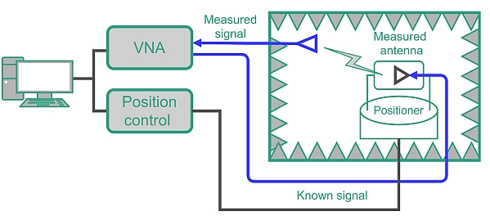
Figure 1.3 Antenna measurement in an OTA chamber using a VNA, functioning both as the signal source and receiver.

CONCLUSION:
After Performing this experiment, now we can observe the frequency response of any given circuit using spectrum analyzer also we can determine the attenuation in db. A VNA can be used to measure the directivity of an antenna or the properties of dielectric materials.

EXPERIMENT NO. 2

AIM: Study of different types of antennas.
EQUIPMENTS: Different types of antennas

THEORY:

Antennas are a fundamental component of modern communications systems. By definition, an antenna acts as a transducer between a guided wave in a transmission line and an electromagnetic wave in free space. Antennas demonstrate a property known as reciprocity, that is an antenna will maintain the same characteristics regardless if it is transmitting or receiving. When a signal is fed into an antenna, the antenna will emit radiation distributed in space a certain way. A graphical representation of the relative distribution of the radiated power in space is called a radiation pattern.

The following is a glossary of basic antenna concepts.

Antenna:
An antenna is a device that transmits and/or receives electromagnetic waves. Electromagnetic waves are often referred to as radio waves. Most antennas are resonant devices, which operate efficiently over a relatively narrow frequency band. An antenna must be tuned to the same frequency band that the radio system to which it is connected operates in, otherwise reception and/or transmission will be impaired.

Wavelength:
We often refer to antenna size relative to wavelength. For example: a half-wave dipole, which is approximately a half-wavelength long. Wavelength is the distance a radio wave will travel during one cycle. The formula for wavelength is

λ=C/f

λ= wavelength of a wave
C= Velocity of a wave in free space
= 3* 10⁸ m/s.
f = frequency of operation.

Note: The length of a half-wave dipole is slightly less than a half-wavelength due to end effect. The speed of propagation in coaxial cable is slower than in air, so the wavelength in the cable is shorter. The velocity of propagation of electromagnetic waves in coax is usually given as a percentage of free space velocity, and is different for different types of coax.

Impedance Matching:
For efficient transfer of energy, the impedance of the radio, the antenna, and the transmission line connecting the radio to the antenna must be the same. Radios typically are designed for 50 ohms impedance and the coaxial cables (transmission lines) used with them also have a 50 ohms impedance. Efficient antenna configurations often have an impedance other than 50 ohms, some sort of impedance matching circuit is then required to transform the antenna impedance to 50 ohms.

VSWR and Reflected Power:
The Voltage Standing Wave Ratio (VSWR) is an indication of how good the Impedance match is. VSWR is often abbreviated as SWR. A high VSWR is an indication that the signal is reflected prior to being radiated by the antenna. VSWR and reflected power are different ways of measuring and expressing the same thing. A VSWR of 2.0:1 or less is considered good. Most commercial antennas, however, are specified to be 1.5:1 or less over some bandwidth. Based on a 100-watt radio, a 1.5:1 VSWR equates to a forward power of 96 watts and a reflected power of 4 watts, or the reflected power is 4.2% of the forward power.

Bandwidth:
Bandwidth can be defined in terms of radiation patterns or VSWR/reflected power. The definition used in this book is based on VSWR. Bandwidth is often expressed in terms of percent bandwidth, because the percent bandwidth is constant relative to frequency.

Directivity and Gain:
Directivity is the ability of an antenna to focus energy in a particular direction when transmitting or to receive energy better from a particular direction when receiving. The relationship between gain and directivity: Gain = efficiency/Directivity.
Gain is given in reference to a standard antenna. The two most common reference Antennas are the isotropic antenna and the resonant half-wave dipole antenna. The isotropic antenna radiates equally well in "all" directions. Real isotropic antennas do not exist, but they provide useful and simple theoretical antenna patterns with which to compare real antennas. An antenna gain of 2 (3 dB) compared to an isotropic antenna would be written as 3 dBi. The resonant half-wave dipole can be a useful standard for comparing to other antennas at one frequency or over a very narrow band of frequencies. To compare the dipole to an antenna over a range of frequencies requires an adjustable dipole or a number of dipoles of different lengths.

Radiation Patterns
The radiation or antenna pattern describes the relative strength of the radiated field in various directions from the antenna, at a fixed or constant distance. The radiation pattern is a "reception pattern" as well, since it also describes the receiving properties of the antenna. The radiation pattern is three-dimensional, but it is difficult to display the three-dimensional radiation pattern in a meaningful manner, it is also time consuming to measure a three-dimensional radiation pattern. Often radiation patterns are measured that are a slice of the three-dimensional pattern, which is of course a two-dimensional radiation pattern which can be displayed easily on a screen or piece of paper. These pattern measurements are presented in either a rectangular or a polar format.

Beamwidth
Depending on the radio system in which an antenna is being employed there can be many definitions of beamwidth. A common definition is the half power beamwidth. The peak radiation intensity is found and then the points on either side of the peak represent half the power of the peak intensity are located. The angular distance between the half power points traveling through the peak is the beamwidth. Half the power is — 3dB, so the half power beamwidth is sometimes referred to as the 3dB beamwidth.

Antenna Polarization
Polarization is defined as the orientation of the electric field of an electromagnetic wave. Polarization is in general described by an ellipse. Two often used special cases of elliptical polarization are linear polarization and circular polarization. The initial polarization of a radio wave is determined by the antenna that launches the waves into space. The environment through which the radio wave passes on its way from the transmit antenna to the receive antenna may cause a change in polarization. With linear polarization the electric field vector stays in the same plane. In circular polarization the electric field vector appears to be rotating with circular motion about the direction of propagation, making one full turn for each RF cycle. The rotation may be righthand or left-hand.

Types of antennas:
- Wire antennas:
Half wave dipole:
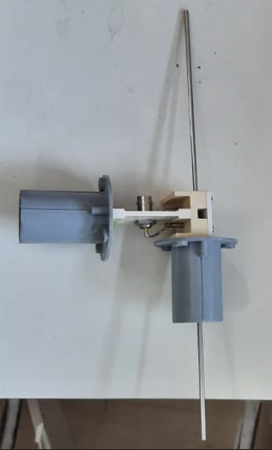

Folded dipole:
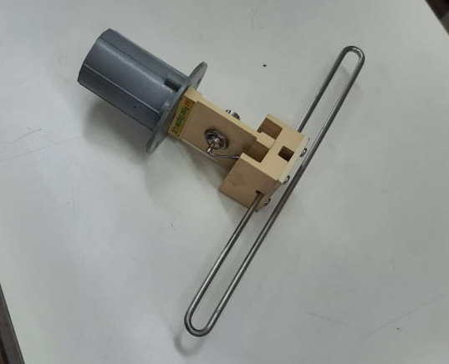

Loop antenna:
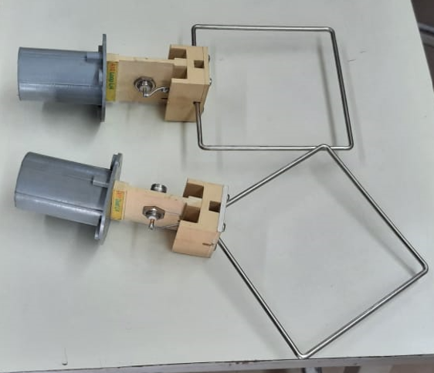

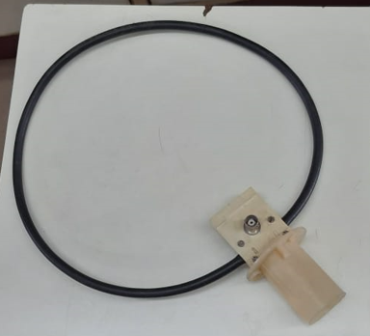

Log Periodic antenna:
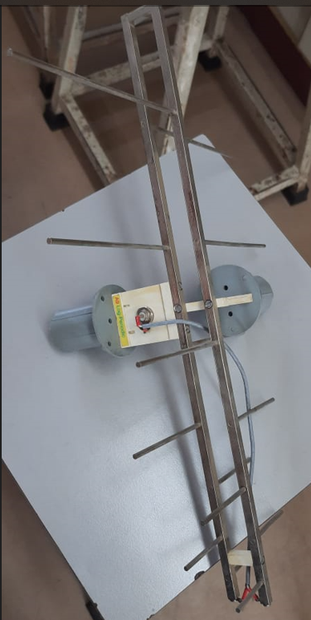

Helical antenna:
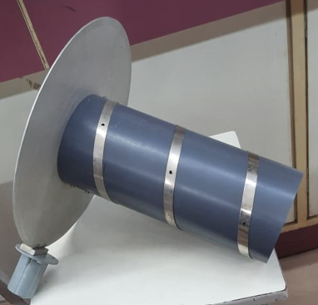

- Array antennas:
Yagi Uda antenna:
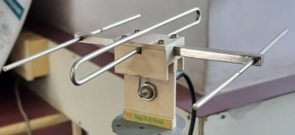

Broadside array:

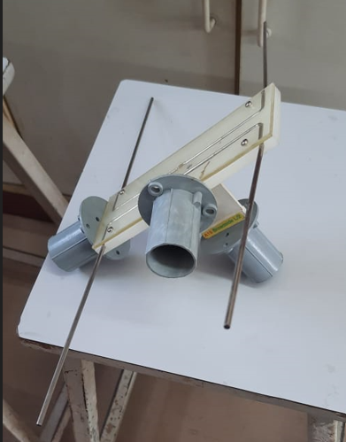

End fire array:
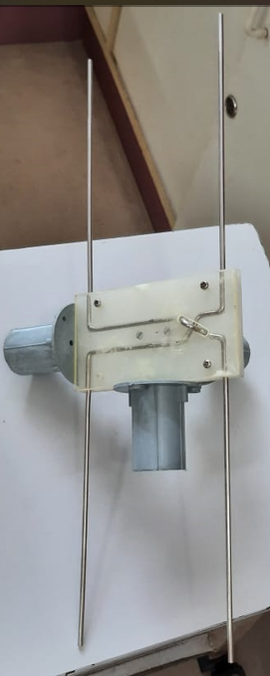

- Reflector antennas:
Parabolic reflector:

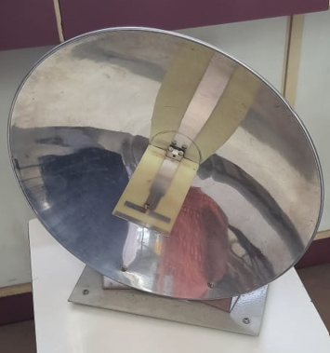
Conclusion:
Study concluded gives vast information about different types of antennas according to the required wired or wireless communication system. We can select the best antenna to fulfil the requirement. Application and working of antenna are studied accordingly.

